Monitoring Task

Task Description:

Install Prometheus and Grafana on a Linux EC2 machine, connect Prometheus to Grafana, and create a dashboard to view metrics.

Techstacks needs to be used :
AWS EC2
- Prometheus
- Grafana
- Node Exporter

EC2 Creation:
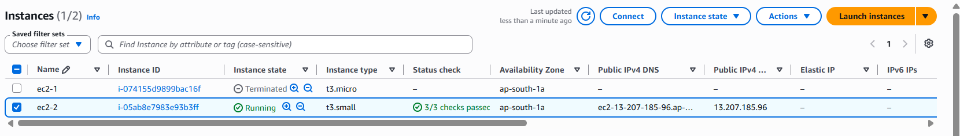
Ports:
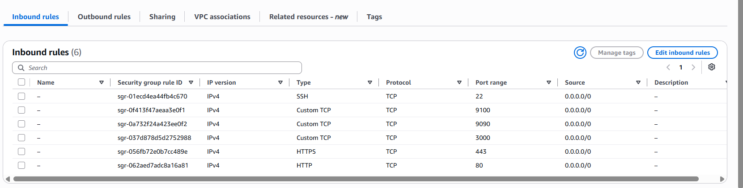
Status: Grafana:
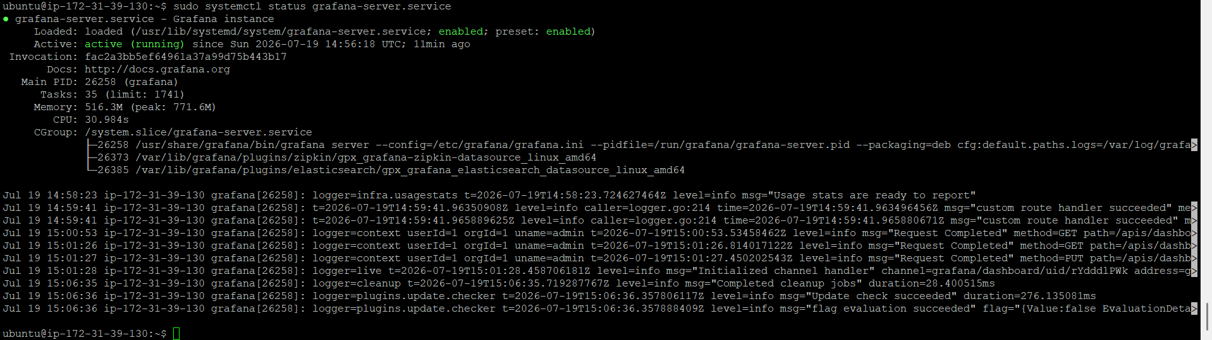
Status: node_exporter.service , Prometheus
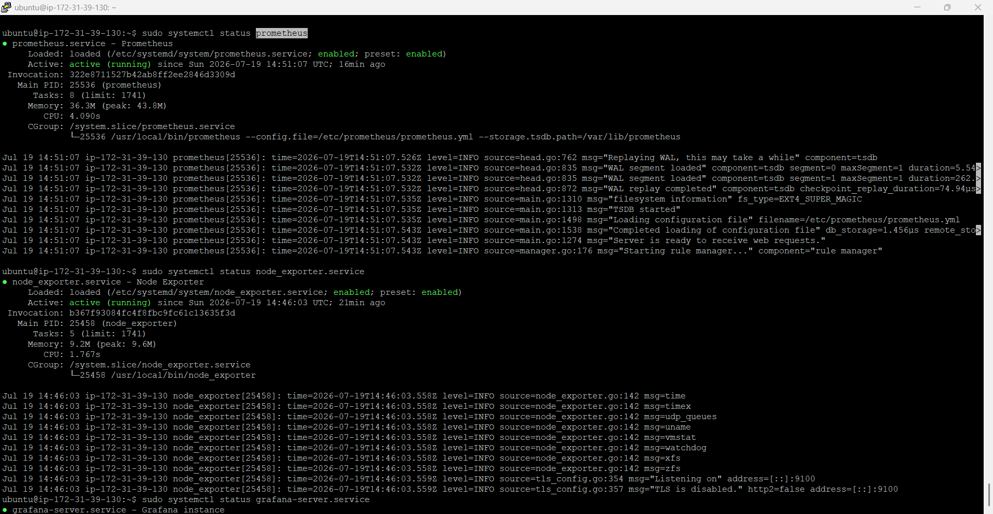
Prometheus
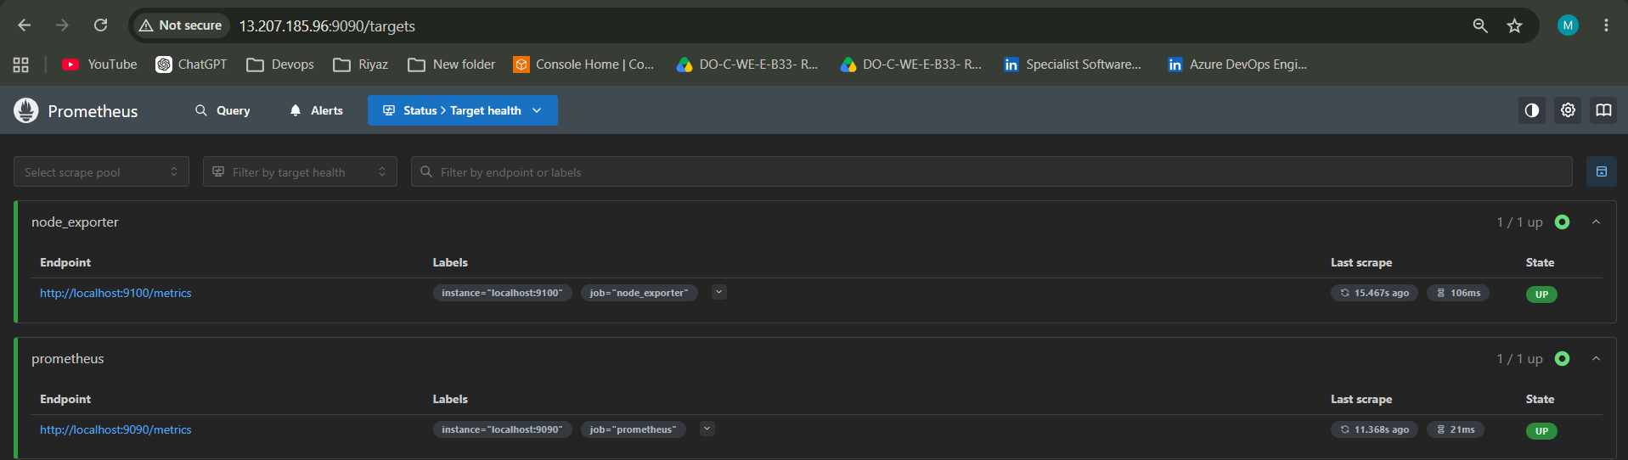
Node Exporter:
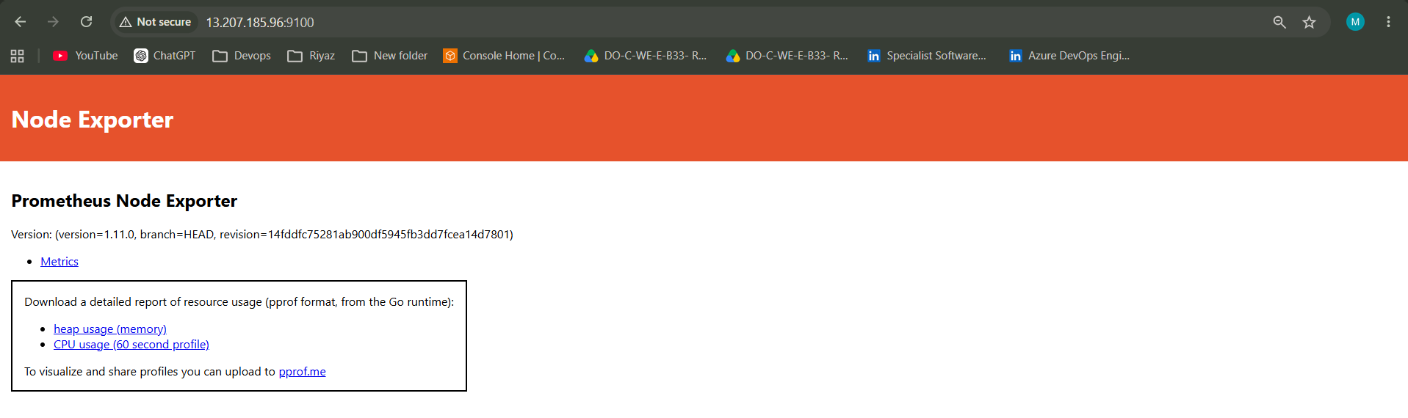

Metrics:
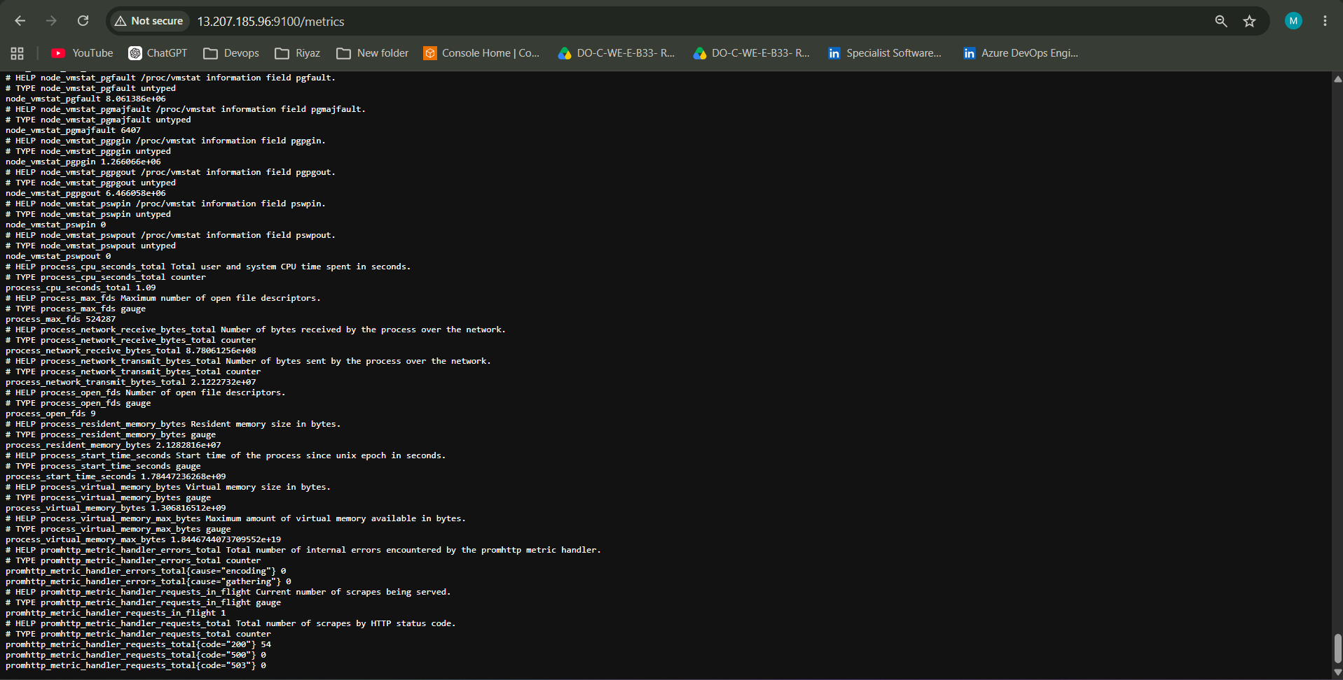
Grafana:
